
CALIFORNIA TUMOR TISSUE REGISTRY
141st Semi-Annual Cancer Seminar

“Evolving Concepts in Soft Tissue Pathology”

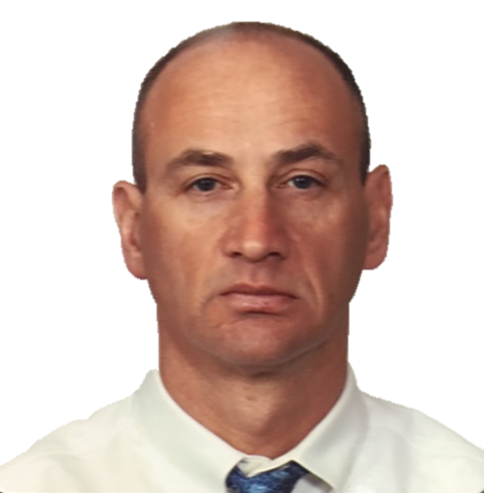
December 4, 2016
8:30 a.m. – 4:45 p.m.

Hyatt Regency San Francisco
5 Embarcadero Center
San Francisco, California, 94111
Phone: (415) 788-1234

Andrew L. Folpe, M.D. Professor and Consultant
Division of Anatomic Pathology
Mayo Clinic, Rochester, MN

Seminar Objectives: At the conclusion of this seminar, attendees will be able to:

1. Recognize the clinical and morphological features of newly or more completely described entities
in soft tissue tumor pathology

2. Effectively apply established and new immunohistochemical markers to the workup of soft tissue tumors

3. Appreciate the impact of advances in molecular pathology to the differential diagnosis of soft tissue tumor

This activity has been planned and implemented in accordance with the Essential Areas and policies of the Accreditation Council for Continuing Medical Education through the joint providership of Loma Linda University School of Medicine and California Tumor and Tissue Registry. The Loma Linda University School of Medicine is accredited by the ACCME to provide continuing medical education for physicians. Loma Linda University School of Medicine designates this Live Activity and Enduring Material for a maximum of 10 AMA PRA Category 1 Credit(s) TM. Physicians should claim only the credit commensurate with the extent of their participation in the activity.
The American Board of Pathology also certifies this activity to provide up to 10 hours of SAM credit (Self-Assessment Module).

Registration Form is on the next page

California Tumor Tissue Registry

December 4, 2016
REGISTRATION FORM

Materials: (“Attendance Only” includes items 1 and 2)
1. 6 hour lecture (Seminar objectives, clinical histories, discuss the role of special studies in diagnosis, therapy,
and counseling, project photographs of study cases and other illustrative materials)
2. Comprehensive syllabus that includes diagnoses, discussion, and appropriate references from pertinent medical literature
3. Glass or digital slides of representative tumors (Full package)

CME/SAMs applies only to the day of the seminar. Full Package can earn up to 10 hrs CME and/or SAMs credit, Attendance only can earn up to 6 hrs CME/SAMs credit. This activity has been planned and implemented in accordance with the Essential Areas and policies of the Accreditation Council for Continuing Medical Education through the joint provider ship of Loma Linda University School of Medicine and California Tumor and Tissue Registry. The Loma Linda University School of Medicine is accredited by the ACCME to provide continuing medical education for physicians. Loma Linda University School of Medicine designates this Live Activity and Enduring Material for a maximum of 10 AMA PRA Category 1 Credit(s) TM. Physicians should claim only the credit commensurate with the extent of their participation in the activity. The American Board of Pathology also certifies this activity to provide up to 10 hours of SAM credit (Self Assessment Module. Disclosure Statement: This program has been planned and implemented in accordance with ACCME essentials and standards. The Loma Linda School of Medicine Office of Continuing Medical Education relies on its CME faculty to provide program content that is free of commercial bias. Therefore, in accordance with ACCME standards, any faculty and/or provider industry relationships will be disclosed and resolved.
ATTENDEE INFORMATION

Name: Phone:

Facility: Email:

Mailing Address:
EARLY BIRD REGISTER
REGISTRATION FEE REGISTRATION AFTER 10/24/16
(Register by 10/24//2016)
*Includes continental breakfast and drinks during breaks.

FULL PACKAGE - Up to 10 CME/ SAMs credit $350 $400
Includes: Glass slides and/or digital slides, Attendance and Syllabus
**Must attend the seminar and send in the answers before 12/4/16 for full CME/SAMs credit
FULL PACKAGE - No CME/ SAMs credit $300 $350
Includes: Glass slides and/or digital slides, Attendance and Syllabus

RESIDENT PACKAGE- No CME/ SAMs credit $225 $300
Includes: Glass slides and/or digital slides, Attendance and Syllabus

ATTENDANCE ONLY- Up to 6 CME/SAMs credit
Includes – Attendance, Syllabus $275 $300

ATTENDANCE ONLY- No CME/SAMs credit
Includes – Attendance, Syllabus $225 $250

RESIDENT ATTENDANCE ONLY- No CME/SAMs credit
Includes – Attendance, Syllabus $175 $175
Payment Information – Make Checks Payable to California Tumor Tissue Registry

Check enclosed Credit Card Master Card Visa

Credit Card # _____________________________________________ Exp. Date: ______________________________________________

Zip code of billing address: ________________ Total Amount: _______________For orders outside the United States of America, please add $40.00

Name on Card: __________________________________________________________________________________________________________

Signature: _______________________________________________________________________________________________________________

Cancellations subject to a 15% overhead charge. MAIL TO: Loma Linda University Pathology Medical Group Or FAX TO: (909) 558-0188
California Tumor Tissue Registry
11021 Campus Ave, AH335
www.CTTR.org PHONE: 909-558-4788 Loma Linda, CA 92350

